**Bangladesh University of Engineering and Technology**

**Department of Electrical and Electronic Technology**

**EEE 428**

**Measurement and Instrumentation Laboratory**

**Experiment 4**

**Signal Processing: Precision Rectification**

Name: Md Maisoon Rahman

Student ID: 1606038

Level: 4, Term: 1

Dept. EEE

**Measurement and Instrumentation Laboratory**

**EEE 428**

Experiment No :04

Experiment Title : Signal Processing: Precision Rectification

Objective :

In this report, the aim is to measure AC Voltage sources through integrated circuits.

Setup:

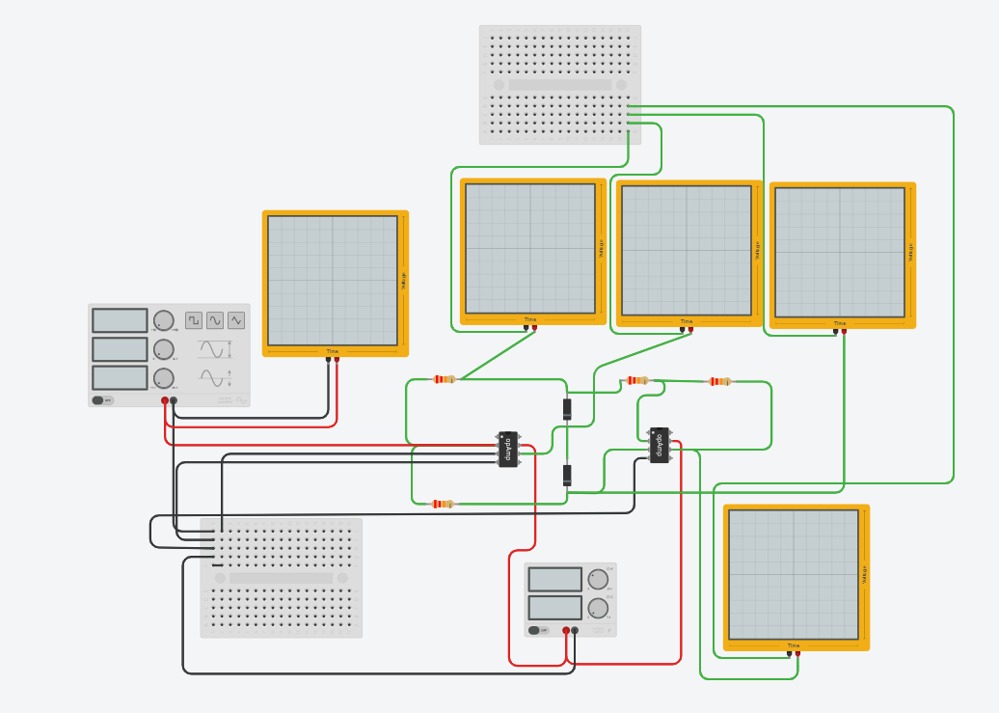

Figure 1 Tinkercad simulation circuit diagram

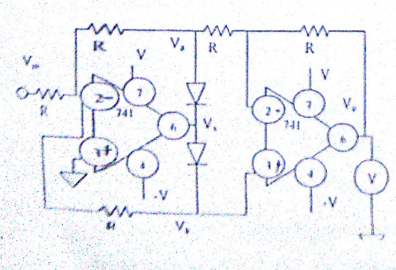

Figure 2 Circuit Diagram

The tinker cad simulation after simulating:

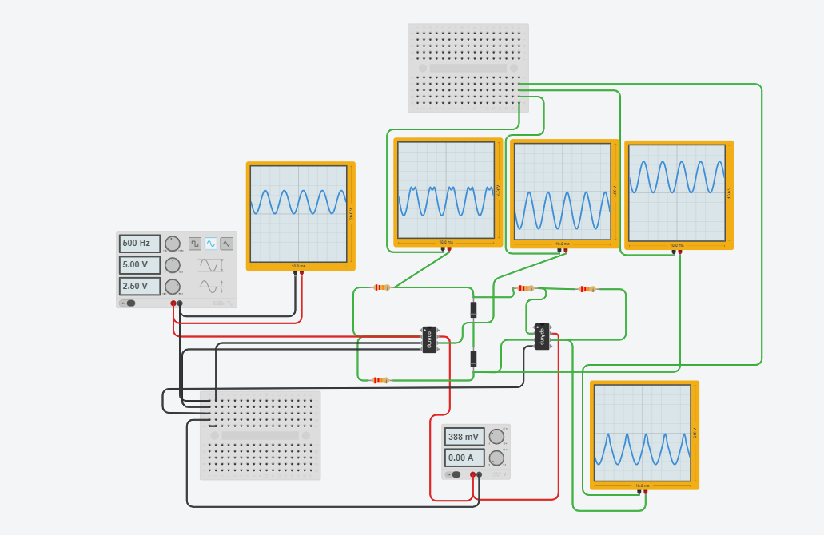

Figure 3 Simulated circuit

The following outputs were observed for Vin,Va,Vb,Vx,Vo

For Case R = 22k Ohm

Vin Va Vx

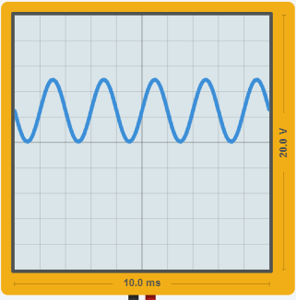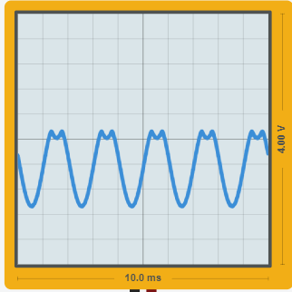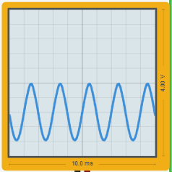

Vb Vo

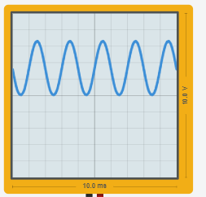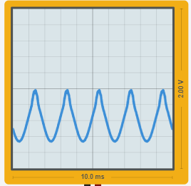

For Case R = 10k Ohm

Vin Va Vx

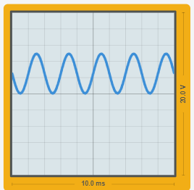 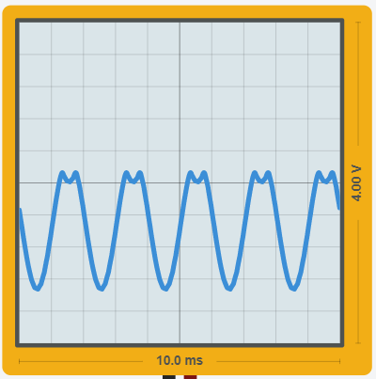 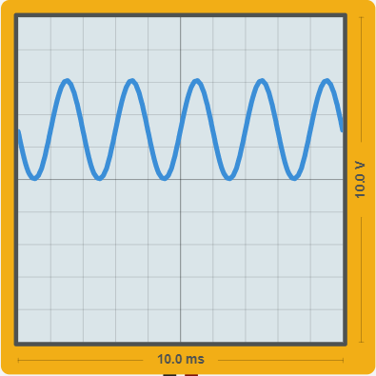

Vb Vo

 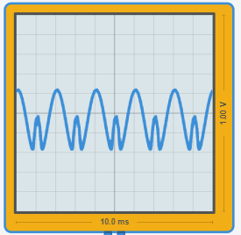

For Case R = 100k Ohm

Vin Vo

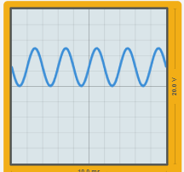 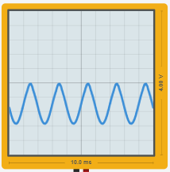

Va Vx Vb

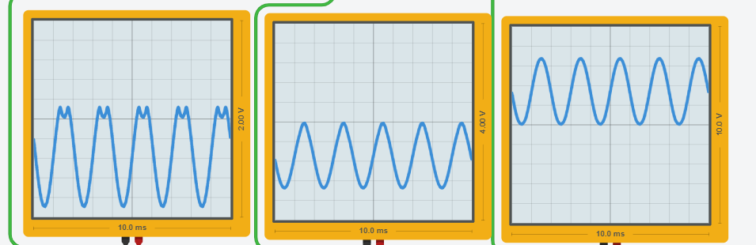

For Case R = 220k Ohm

Vin Vo

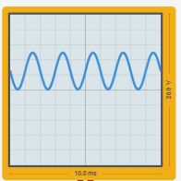 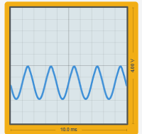

Va Vx Vb

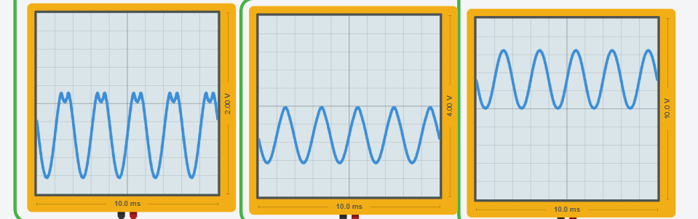

Conclusion :

Throughout the experiment,the full have rectification of an ac voltage was observed.